Title : Import the data warehouse data in Microsoft Excel and create the Pivot table and
Pivot Chart.
Name : - Mehatab Mahibub Sanadi
Roll No. : - CO4050
Class : - BE Computer
Subject : - Business Intelligence
*********************************************************************
PART 1: Import Data Warehouse Data into Excel
Step 1: Open Excel
Launch Microsoft Excel

Step 2: Import Data from Database
Go to Data tab
Click:
Get Data → From Database → From SQL Server Database

🔹 Step 3: Enter Connection Details
Enter:
Server Name (e.g., localhost)
Database Name (your Data Warehouse)
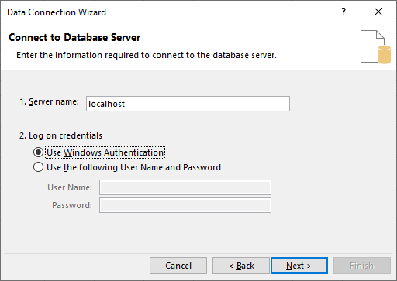

Step 4: Choose Table
Navigator window opens
Select:
Fact table (e.g., Sales / Attendance)

Step 5: Verify Data
Data will appear in Excel sheet (rows & columns)
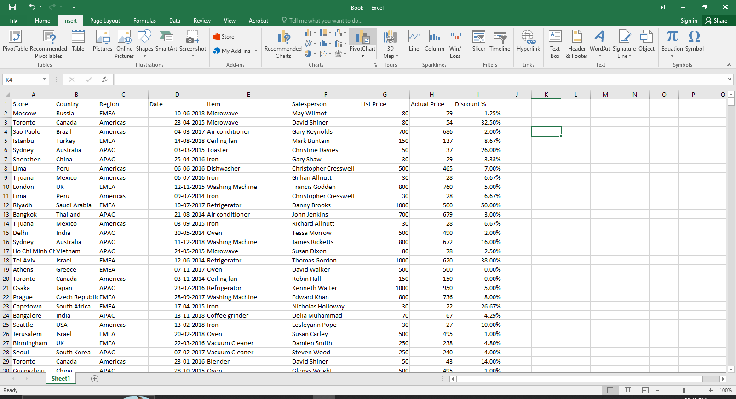
PART 2: Create Pivot Table in Excel
Step 6: Select Data
Click anywhere inside the imported table
Step 7: Insert Pivot Table
Go to Insert tab → PivotTable
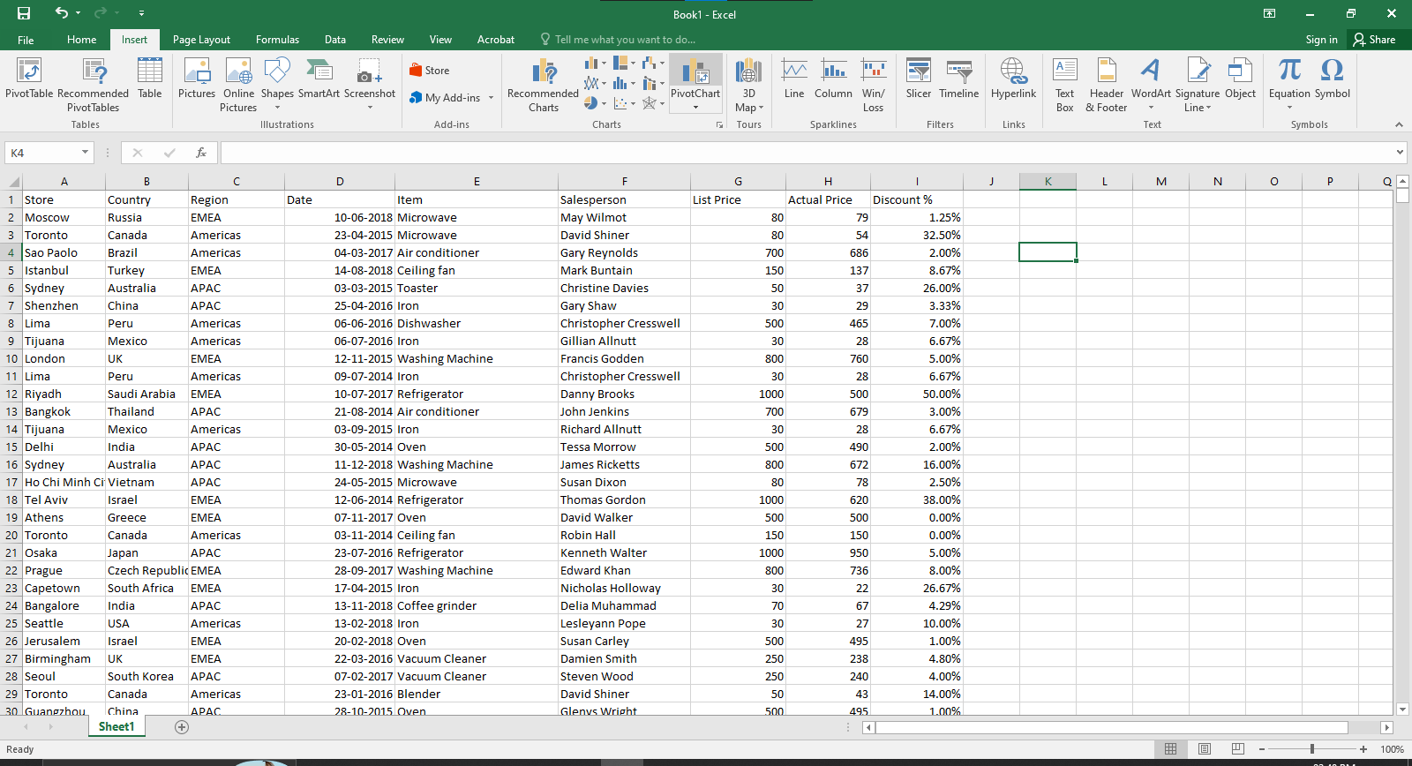
Step 8: Choose Location
Select:
New Worksheet (recommended)
Click OK
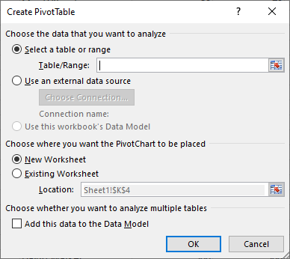

Step 9: Add Fields
In Pivot Table Fields panel:
Drag:
Rows → Category / Student / Product
Columns → Date / Subject
Values → Sales / Count / Marks
Filters → optional (Region, etc.)

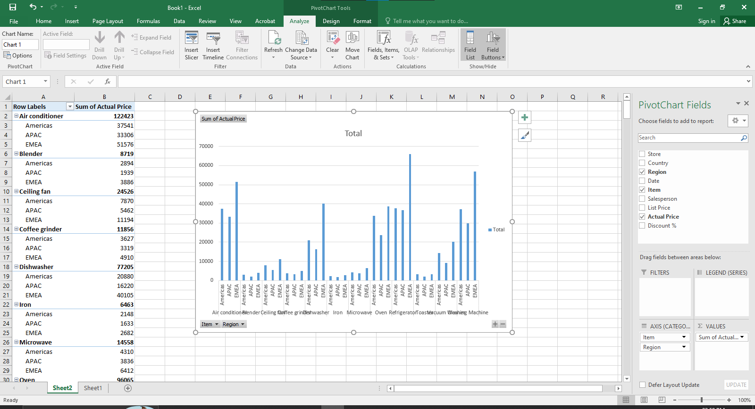
Conclusion: In this way we pivot table and pivot chart using Microsoft Excel.

